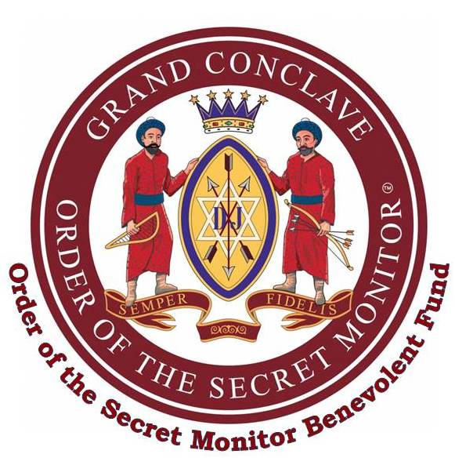

OSM Benevolent Fund
Match Funding
Application Form

Name of Province / District / Conclave:

Registered Charity Name and Number:

Provide details of the capital project you wish to support:

Amount to be matched by the OSMBF:
£

Approved & e-signed by: Date:
Provincial/District Grand Supreme Ruler

- Conclave applications are to be sent to your Provincial/District Recorder for authorisation.
- Funding limit is £1,000 per Province/District per year (April – March).
- Email only to d.coleman@mmh.org.uk Call 020 7747 1187 for more information.
OSMBF / MF Application Guide & Form

