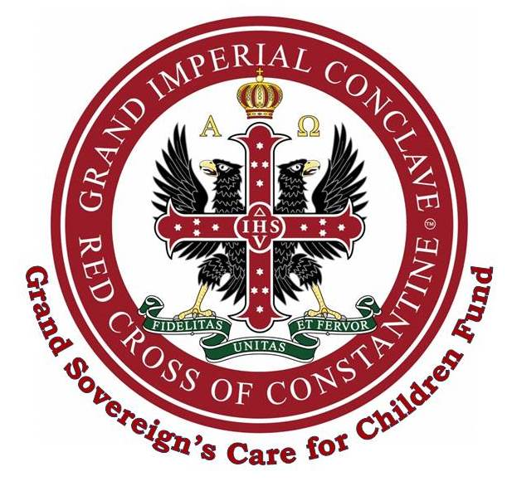
Application Form and Guidelines for Submitting a Proposal for Funding

The Fund makes donations to Charities and other organisations whose work is directly concerned with the welfare and care of children.

It does not give funding for things such as conferences, fund raising events, wages or general running costs.

Please note that if any charity nominated by your Division that has successfully received a grant in the previous 2 years, then the application will not be accepted.

If you are unclear as to whether your request will be eligible, please contact Darren Coleman-Heald, Charities Manager at Mark Masons’ Hall on 020 7747 1187 or email d.coleman@mmh.org.uk

What to do
Once a suitable children’s charity has been identified then a written proposal should be put together using the form below.
It should include the following information:
- How much the request is for
- What the funds to be used for
- Who will benefit from the grant
- What is the aim of the charity and who does it help
- Any other supporting documentation such as flyers, brochures, quotes or estimates for equipment or works, etc
The information should then be submitted to your Divisional Recorder to be reviewed and endorsed by the Intendant-General.

Once approved, the documents will then be forwarded to Darren Coleman-Heald, Charities Manager at Grand Imperial Conclave, Mark Masons’ Hall by email d.coleman@mmh.org.uk for consideration.

The more information about your charity that you can provide, the easier it will be for a decision to be reached.
Issued by
The Charities Office
Grand Imperial Conclave
Mark Masons’ Hall
86 St James’s Street
LONDON
SW1A 1PL
020 7747 1187
d.coleman@mmh.org.uk

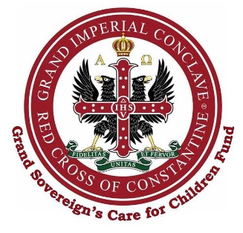

Grand Sovereign’s
Care for Children Fund

Name of Division / Conclave:

Registered Charity Name and Number:

Provide details of the project you wish to support:

Approved & e-signed by: Date:
Intendant-General of the Division

- Email completed form only to d.coleman@mmh.org.uk
- Please remember to attach any supporting documents, further information and quotes/estimates for your chosen project.
- Call 020 7747 1187 for more information.
GSCFCF Application Guide & Form

